Revising the Select Query I

Query all columns for all American cities in **CITY** with populations larger than 100000 . The *CountryCode*

for America is USA .

**Input Format**

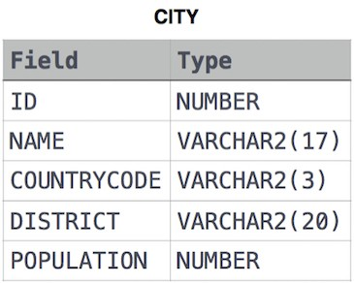The **CITY** table is described as follows:

**Solution :-**